Back to School

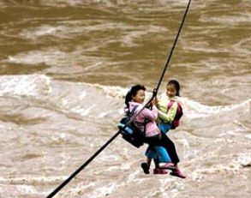
Going back to school in China is no joke. A bridge is to be built in a Chinese village where children are forced to cross a raging torrent on a steel cable to get to school.
Nearly 500 children, from Maji village in Fugong town, Yunnan province, cross the most dangerous stretch of the Nujiang River each day. They fasten themselves to the cable with a metal carabineer and a rope and slide across the 200 metre wide canyon, reports the Beijing News.
The youngest student, A Qia, 4, has to go over by herself each day. 'I have to hand walk for about 60 metres, since my light weight makes me stop about two thirds of the way across,' she said. The villagers say that usually four-year-old children are taken by their parents, and begin to go by themselves from the age of five.
A Pu, 5, who was stuck in the middle of the cable for nearly 20 minutes once, told reporters, 'I used to dream of having a bridge, but then I learned that my dream was too expensive.' However, officials have finally agreed to spend £35,000 on a bridge after a TV programme was made about the children's dangerous daily journey.
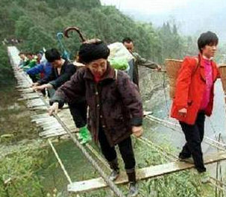
Time to Add/Delete Teachers From Your Subscribers List.
The beginning of the year is a great time to have a check of who, at your school, has access to the website. The person on your staff who manages this has a ‘Manage Users’ tab on their login and can approve new sign ups and unsubscribe teachers who have moved to other schools.

Independent Survey.
We have asked an independent person to conduct a survey with the request for unbiased feedback on our worksheets, website and future directions for our company.

All subscribers will be contacted this term and invited to spend a few minutes answering the survey questions. We will not be privy to the individual responses but will use the outcomes as presented to us by the researcher to help us improve our product and services.

Thank you in advance for your participation!

Have a Great Start to 2013.
Early one morning, a mother went in to wake up her son.
'Wake up, son. It's time to go to school'
'But why, Mom? I don't want to go.'
'Give me two reasons why you don't want to go.'
'Well, the kids hate me for one, and the teachers hate me, too!'
'Oh, that's no reason not to go to school. Come on now and get ready.'
'Give me two reasons why I should go to school.'
'Well, for one, you're 52 years old. And for another, you're the Head teacher!'
If you would like to unsubscribe to this newsletter please use the reply button and send us ‘unsubscribe’ as a message.
Like us on Facebook http://www.facebook.com/pages/Great-Little-Readers
⇨Forward this newsletter to a teaching friend!
www.greatlittlereaders.co.nz
Quality resources for great teachers!

